Construction
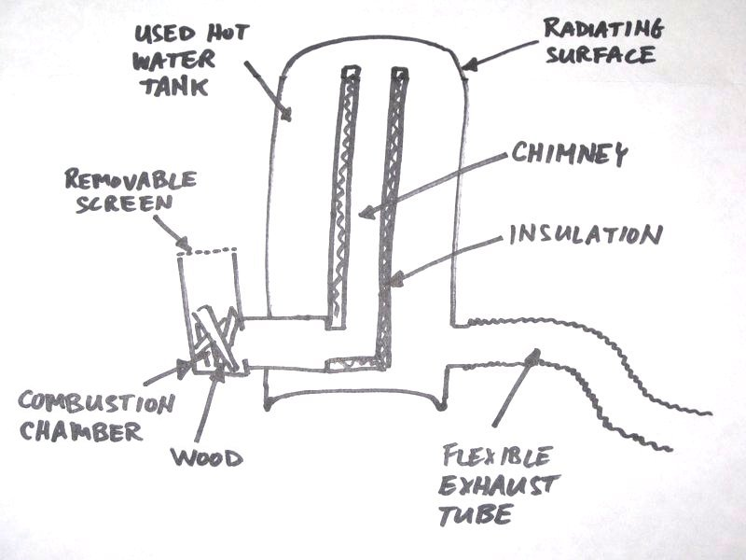
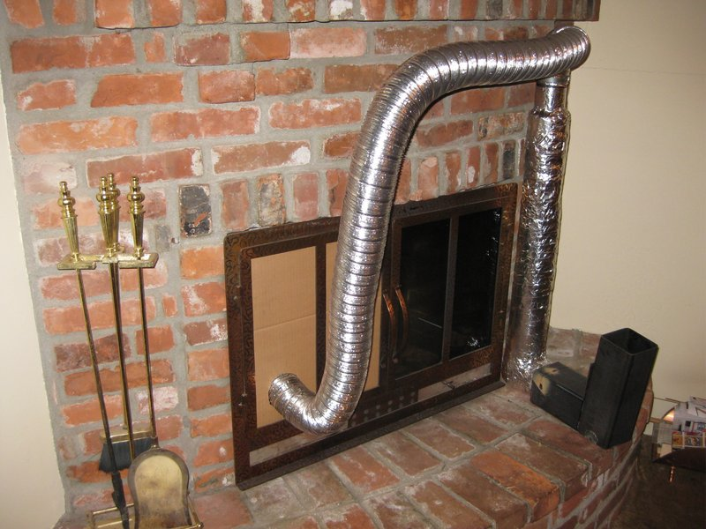
Rocket stove mass heaters are often built from steel drums. These are convenient since they have a flat top that can also be used for cooking. I used an old electric which had jst been replaced since it was corroded and leaking, some 3″ diameter steel pipe, some 4″x4″ square tubing, and some flat steel plate, all about 1/8″ wall thickness (though that is probably thicker than necessary). I also used some flexible aluminum tubing (dryer ducting) to feed the exhaust from the rocket stove into my existing fireplace.
To the left is a picture of the internal parts of the stove (combustion chamber and chimney) set up for initial testing to make sure it would generate enough draft for vigorous combustion. The aluminum flex tubing is connected to the top of the chimney for testing only. In the finished product it will be connected to the side of the stove. The chimney is insulated with about 1″ of Roxul (a rock wool insulation that will tolerate higher temperatures than fiberglass insulation) and wrapped with adhesive aluminum furnace tape to hold the insulation in place.
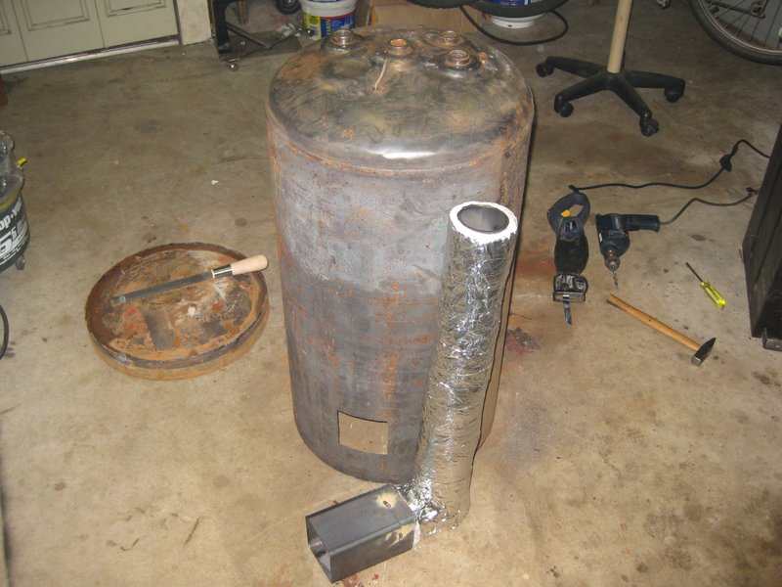
The next image shows the hot water tank cut to accept the combustion chamber and chimney, While below shows the combustion chamber and chimney being welded into the side of the hot water tank. Note the block of wood between the end of the chimney and the inside surface of the tank to ensure an appropriate gap for the exhaust gases. This piece of wood will be removed after the chimney is welded in place.

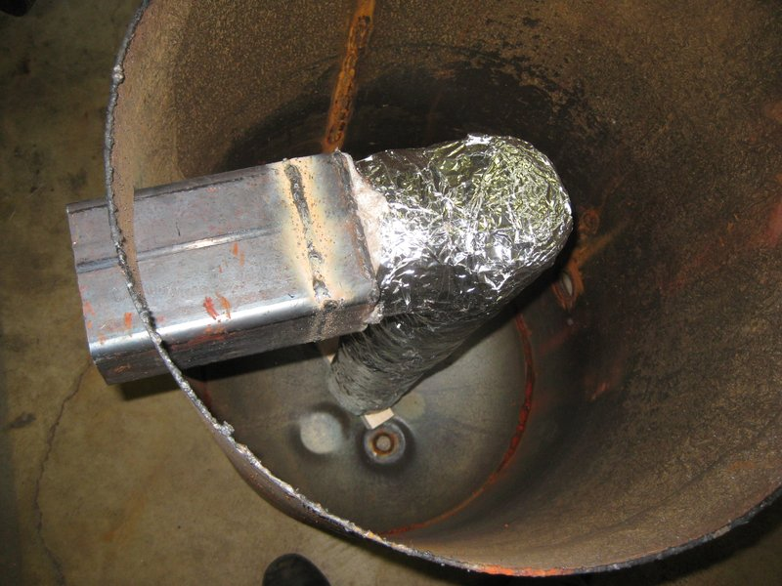
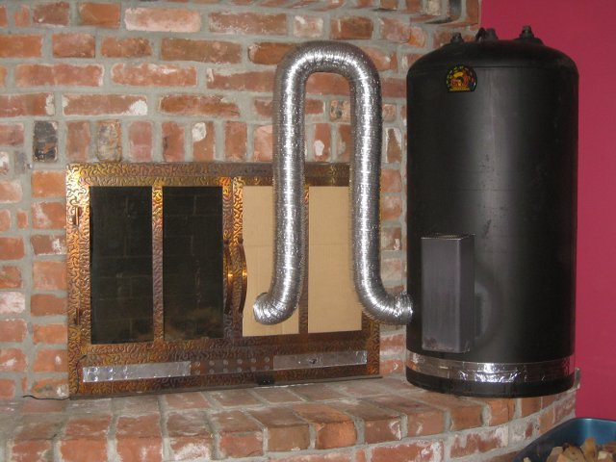
… and after a bunch more welding and a paint job that I neglected to take any pictures of … viola! … the finished product. The silver band around the bottom isn’t a racing stripe. It covers the seam where I tack welded the bottom of the tank back on. I did not want to weld it on permanently since I may want to disassemble the stove later for inspection.
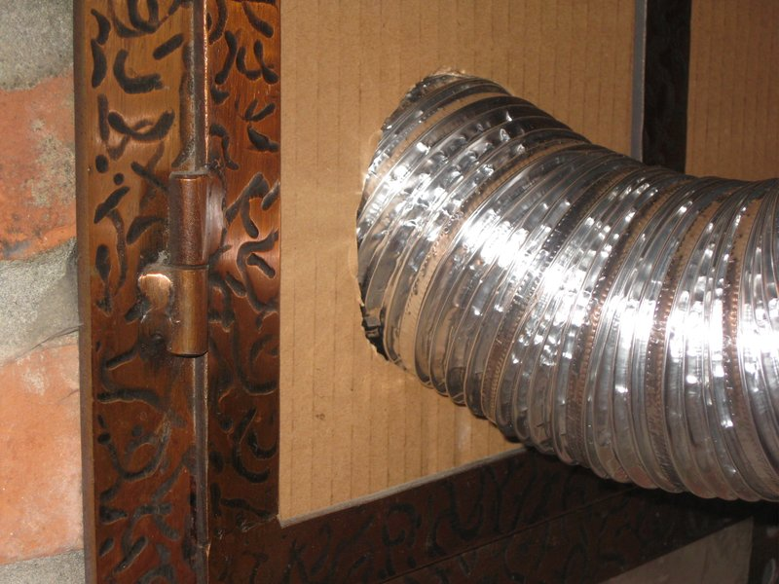
Notice that I removed a glass pane from the left door of my fire place and replaced it with cardboard. The aluminum flex tube passes snugly through a hole cut in the cardboard to expel the exhaust gases into the fireplace where, still warm, they rise and exit through the existing chimney. I know you’re probably thinking I must be crazy to use a combustible material like cardboard for this purpose, but the fact is that the exhaust volume from this stove is so low and the stove is so efficient at removing heat from the exhaust that this aluminum tube reaches a maximum temperature of only about 60 degrees C during operation. That’s cooler than a typical cup of coffee. The top of the stove gets much hotter, of course.
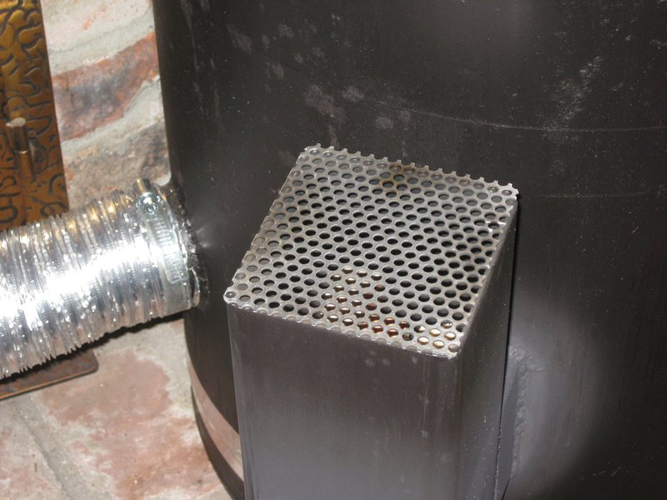
I also made a simple metal screen that can be placed over the combustion chamber to prevent sparks from popping out into the room where they could ignite something (or more likely just leave burn marks as they smolder on the carpet). I have another cover, not shown, that is a solid steel plate. It’s useful to quickly extinguish the fire and to prevent air infiltration when the stove is not in use.

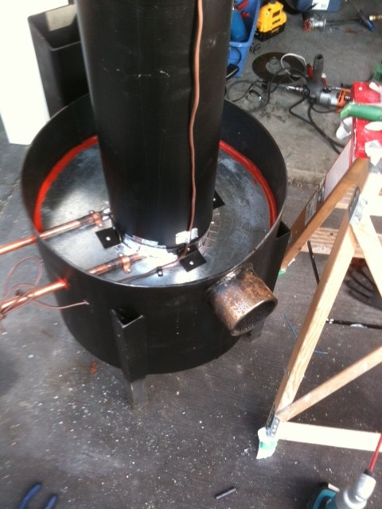
using a large water reservoir for thermal mass with a coil of copper tubing wrapped around the internal chimney of the stove for heat transfer.


