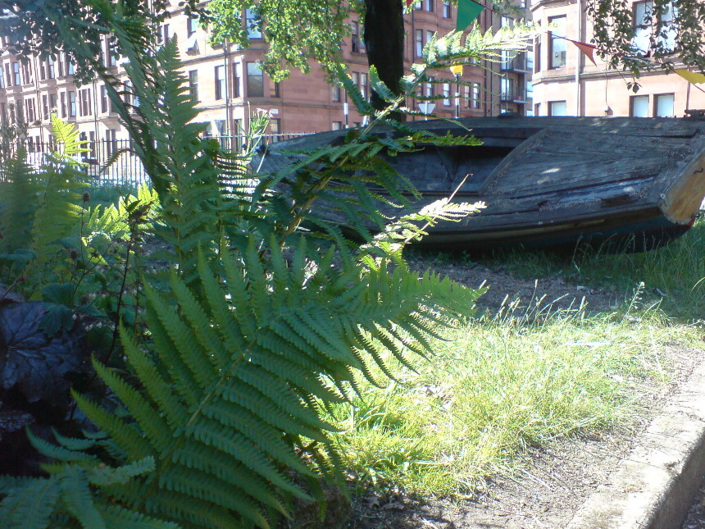
Elder Farm
In the 19th Century, philanthropists concerned for the health and welfare of children and their families living in dwellings built around heavy industry took action to make a difference. John and Isabella Elder and Isabella's brother John Francis Ure were three such souls
Govan as the centre of a heavy ship building industry on the back of which many fortunes were made, attracted men from all over Scotland many from rural and fishing villages. Families of the men who had flocked to the city to build and fit out the ships, were crammed into small living spaces.
In 1884, Isabella Elder spent over £37,000 on the purchase of "certain lands situated at Fairfield in the parish of Govan" , and at further "considerable” additional cost, buildings were added, trees and shrubs planted, walkways and carriageways laid :
"... to provide a suitable public park and recreation ground for the inhabitants of the Burgh of Govan in the immediate neighbourhood of which my husband carried on the business of an Engineer and Shipbuilder and in the welfare of which he ever manifested a deep interest."
The property referred to as "The Park", and Elderpark, was placed into the care of the Commissioners of the Burgh of Govan with certain conditions.
Elder Farm Community Garden
Wishing to honour Elder wishes to benefit the community, Ian Sharp cleared the broken glass and rubbish and brought in planter and tires, creating a community garden in the grounds of Fairfield Farm Steading
Currently Fairfield Farm Steading, a B-listed building of some historic importance, is viewed to be an eyesore and dangerous. When the gates are open, the “keep out” sign sends a confusing message to visitors. Locked gates provide a challenge to any red blooded youngster, most of whom find they are well able to climb most of the barriers, effectively leaving services and adults locked out while youngsters are able to roam at will unless gardeners are present.
Ian decided to grow organic foods and plants for the local community to enjoy, hoping to encourage folk to convert their own back yards and gardens into food for bees, and in the doing, learn more about nature and gardening. Some stayed to help out and learn, many of them unemployed for one reason or another, but sadly, these days active workers are short on the ground. Introduction of sanctions, reduction of hours job seekers are allowed to work on voluntary projects and the transient nature of city dwellers may be factors. Increasing hours spent on job applications under schemes with tax incentives that only apply to workers under 25years, is not always favourable to mental health. And as yet there are still no protections or incentives for workers to tackle corruption, let alone effectively control any business which despite the facade are actively streamlined towards collecting a fast buck without regard to future business, community / worker health / customer satisfaction, all of which seriously threatens to undermine community physical and psychological health
Urban gardening projects such as ours, have been shown to benefit physical and psychological health, encourage alternative thinking, much of which is quashed by the time students reach college. Currently there are communities virtually alienated from the very ground they walk on as colleges and the media teach youngsters to fight germs, dirt and faulty tools. Urban projects can help city community members from this ground level experience, discover abilities they were previously unaware of.
Moira Bori has tried to further Ian Sharp's interest in emphasising the role bugs and bees play in our survival, the fun and joy nature brings and the many gifts your God and mine have chosen to bestow should we simply choose to stop, look and listen

Elder Farm Fairfield Steading Derelict Building
Various groups have tried but so far no group of community members have joined in a determined bid to restore the B-listed derelict building of some historic importance at the heart of the project despite the clear benefit evident potential of such a project to the communities of Glasgow City especially those surrounding Elderpark. Local feeling that a sustainable solution a would not only tie in with current use of the space, and interest in environmental issues, but would also provide valuable specialist working experience and ensure future funds go into the community and their projects, not high running costs.
Happily the government is keen for citizens to engage in healthy living and thinking. Community health, environment and land management are high on the agenda, and how better to engage the public with many of those issues than by redeveloping your own historic derelict building and growing your organic own right here in the city.
The redevelopment of the building is not only an issue of heritage right and community health, but also makes safe a site which even with the presence of garden workers to engage with youngsters and warn them about the dangers, remains a threat to the community. Previous attempts to restore the building have apparently failed in mutual agreement on eventual outcome while respecting the conditions of deed of gift :
First - The Park shall in affectionate remembrance of my said husband and also of his father the late David Elder be termed and in all time coming bear the name of the Elder Park
Secondly - It shall at no time and in no circumstances be competent for the said Commissioners of their foresaids to alienate or give out on lease any portion of the Park
Thirdly - The Park shall be occupied and possessed as a public park principally for the use and enjoyment of the inhabitants of the said Burgh in the way of healthful recreation by music and amusements and for no other uses or purposes whatever
Fourthly - Not withstanding the preceding article it shall be competent to the said Commissioners to erect upon the east side of the Park a public reading room or museum and hall for the use of the inhabitants of Govan
Fifthly - No games shall at anytime be allowed to be played on any portion of the Park
Sixthly - The park shall at all times be kept and maintained by the said Commissioners in the like good order and condition in which it is at the date hereof
Seventhly - Having reference to my desire to secure for the inhabitants of the Burgh healthful recreation no drains unless required for sanitary purposed connected with the park itself and no thoroughfares through the park shall be permitted nor shall any gates be opened at any places other than those at which gates have already been erected
Eighthly - If at any time the Commissioners shall for the purpose of effecting any necessary work in the course of the year deem it proper to close the park wholly or partially for a few days either consecutively or otherwise but not exceeding seven days in the whole unless from the nature of the work a longer time is necessary they shall be entitle to do so
Ninthly - It shall be incumbent on the Commissioners to provide a good band of music in the Park twice a week in summer that is from thirtieth April to thirtieth September in each year and in winter at such times as they may find suitable. Further but subject to such regulations as to situation and time as the Commissioners may from time to time deem proper other bands of music may be allowed to play in the Park
Tenthly - The park shall be used and occupied in accordance with the Bye Laws and Regulation hereto annexed. But it shall be competent to the said Commissioners and their foresaids from time to time to frame and publish such new or other regulations and byelaws for the proper use and protection of the park as they may consider necessary.
Eleventhly - During my life no such regulations and byelaws shall have any binding effect unless confirmed by me and by the Secretary of State in terms of the Public Parks (Scotland) Act 1878 and after my death no such regulation and byelaws shall have any binding effect unless and until confirmed by the Secretary of State
moreover it shall not be competent to the said Commissioners by any such regulation and byelaws to be made by them to alter or interfere with any of the fundamental conditions herein before set forth. and I consent to registration hereof for preservation, In Witness Whereof these presents consisting of this and the five preceding pages the first page wereof is impress with a stamp denoting a duty of ten shillings all written by etc etc (named witnesses and signatories)
These are conditions some city citizens by nature find it hard to get their heads around,but well protected by Govan citizens
Elder Farm Survey
A survey was sent out to members of the Greater Govan Community asking for an opinion as to a preferred use of building. Over 1000 replies were returned completed with an overwhelming request for park toilets(for which the building was primarily featured in Lady Elder's design), along with enthusiasm for workshops and ecological community space. A reasonable solution, which seems to sit comfortably with the Conditions of the Deed of Gift, survey returns and current trends would be to restore downstairs as a workshop storage space with public toilets and small kitchenette / community eating space and the upper floor as a flat for eco student guests from other countries to use on condition they work with local communities on eco energy / agricultural / transport / housing projects all of which our city community is aware of through internet and media
Folk ask that this project at the very least, deliver training and work experience to locally unemployed workers, albeit bringing in training and guidance from experienced professionals to oversee working sustainable solutions on the build. It has been noted that National Trust works may soon be needing workers with experience and working understanding of environmentally sustainable solutions to reduce the carbon footprint of listed buildings.
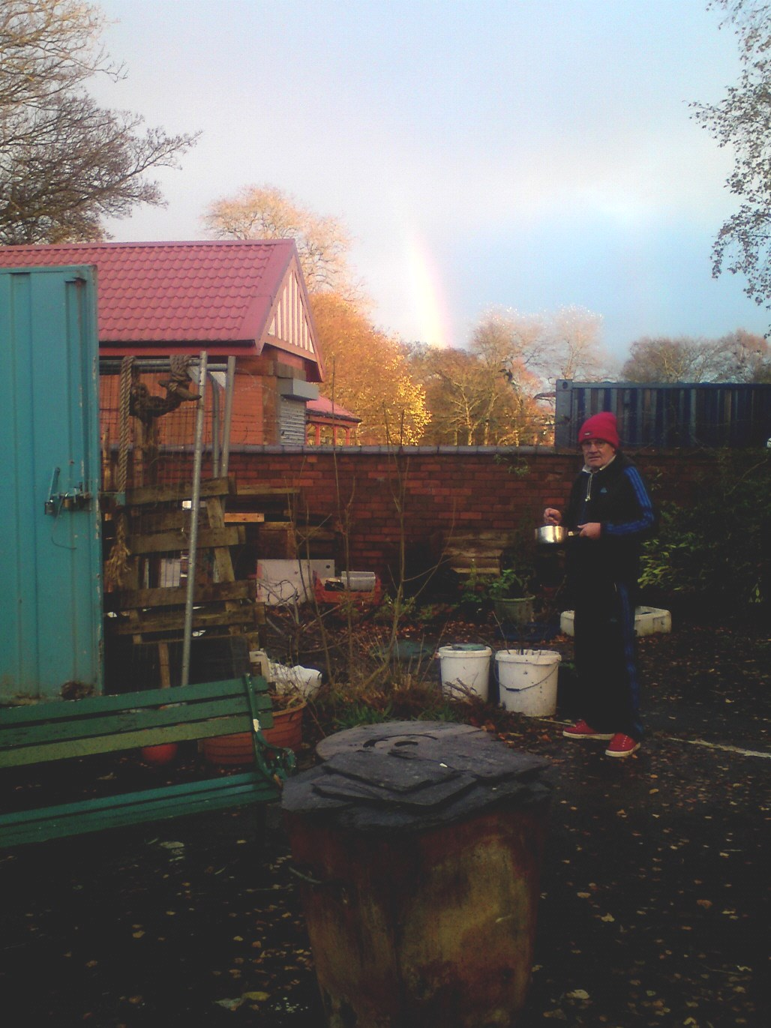
One solution which has been looked at is to restore the upper level of the building as accommodation for an eco- friendly keeper or permaculture / ecological students to occupy rent free, on condition they work with Glasgow eco groups around the local and city communities, while the lower level is restored to park toilets, workshop and storage spaces, with a view to further eco projects in the future
Getting Involved
We at Elder Farm Community are always looking for volunteers with an interest in community, education, arts and crafts, and / or permaculture theory, to help grow food, and / or take part in or run workshops for the community
Anyone interested in joining a pressure group to get the building fixed and safely restored for community use would also be warmly welcome. Look out for a petition still available at Elder Farm or viewed and downloaded at http://elderfarm.jimdo.com/elder-farm-project-survey/
email : elderfarm.govan@gmail.com Find us on Google maps G51 4AA
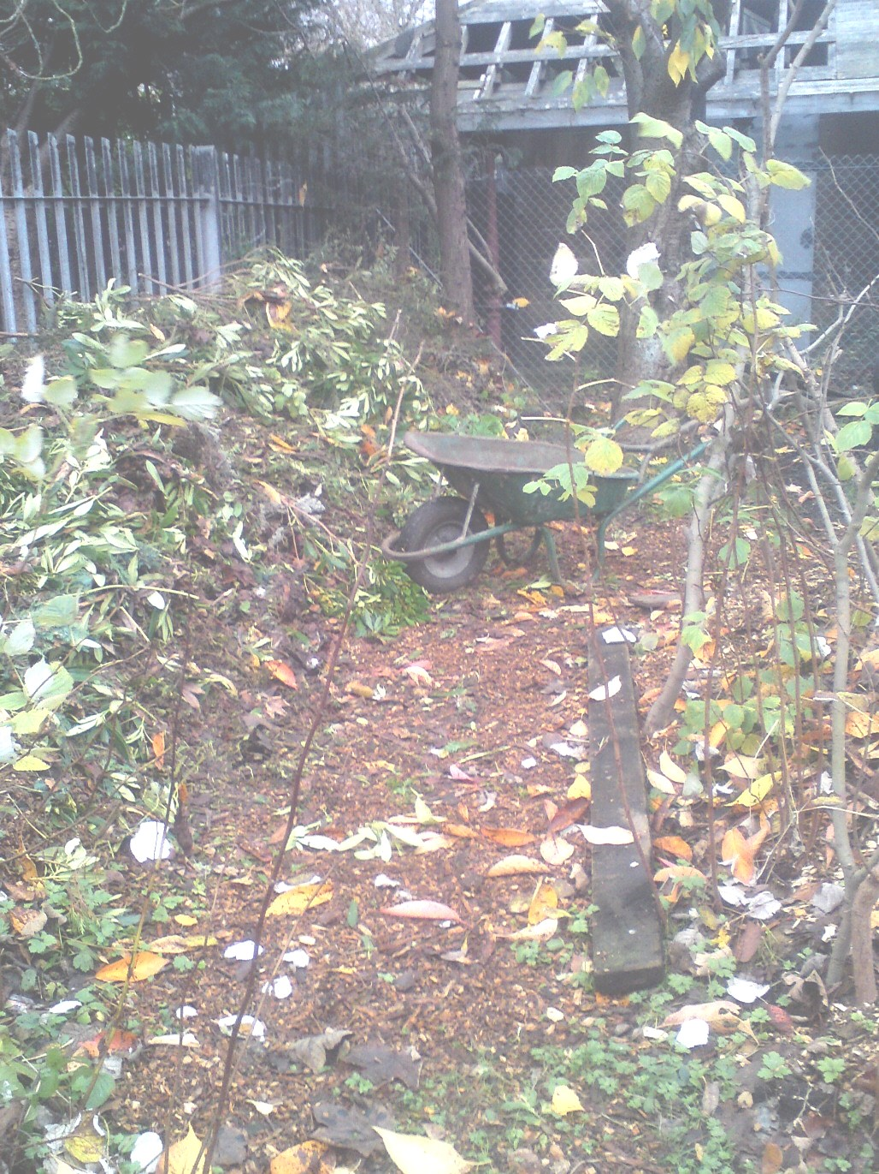
Pop in and learn more. Now winter is ending the garden will begin once again to be open as workers are able to keep it so especially Saturdays. If the gate is open, please pop in and have a look around. Help the environment, talk to the plants, be creative, start a workshop, learn some skills, meet some people, or just relax and enjoy the space , all of which brilliantly helps reduce the negative impact the human race has on the environment, global warming and the ozone.
Elder Farm (NE side of Elder park, entrance currently from the Govan Road by the pedestrian crossing at the foot of Aboukir St)
- Facebook • Elder Farm Community Garden Group
- Facebook • Elder Farm Community Trust Group
- Jimdo • early years to Jan 2013 - http://legup.jimdo.com
- Jimdo • following years until Jan 2014 - http://elderfarm.jimdo.com
- Jimdo • 2014 onwards - http://elderfarm2.jimdo.com

